Lab Report
Student’s Name
Institutional Affiliation
Date

Introduction
In cases where objects are balanced on a pivot, the moment of force exerted on either side must remain at equilibrium with the moment of forces on the pivot opposite side. According to the moment's principles, the total sum of the anticlockwise turning effect should be equal to the effect felt at the clockwise moment when in equilibrium (Song & Park, 2020). The Lab experiment investigates different moments(Torques) under certain conditions.
Objectives
- The experiment determines factors affecting the balance of two objects
- Predict the changing position of a mass to the balance.
- Determine the masses of unknown objects
Procedure
- Open the Phet Simulation Balancing Act
- Select 'intro' tab.
- Apply various weights to test the balance on the board
Case-1
A 5kg is placed at the 2M mark to the left of the pivot. Where should a 10 kg trash be placed to balance on the board?
Calculations
The moment about the turning point is the perpendicular distance multiplied by force.
Moment=force x perpendicular distance
F1xd1 = F2xd2
Force= mass x acceleration
F1= 5kg x 9.8m/s2 = 49N
F2=10kg x 9.8m/s2 =98N
49N x 2M = 98N x d2
The distance of 10kg from the pivot (d2) = 1 M to the pivot's right.
Case-2
- What happens when the supports are removed?
When the supports are removed from the system, an unstable equilibrium will be experienced upon displacement. The balance board encounters a net force or tongue in the same direction as the equilibrium's displacement. An opposite net force will then be experienced on the opposite side of the balance to stabilize the system.
- What happens if 80kg adult is closer to the pivot
The 30kg is much lighter than 80kg, and for that reason, the distance of 80kg from the pivot is much less than 30kg. Now, when 80kg has further moved away to the pivot, the system will lose balance. The turning effect of the force exerted by 80kg will be greater than that of 30kg. When these supports vary in moments of force, the system will not be at equilibrium. The longer the distance from the pivot, the greater the turning effect of force.
- What happens if 30kg child is closer to the pivot
The system will lose balance as the adult exerts a more significant turning effect. The side of the adult will move up, and the child will lose balance. The moment of force will increase on the adult side and decrease on the child side. When turning effects are not equal, the system will become unstable, hence losing its equilibrium.
- Balance Lab change ideas
- The lab should consider the irregular shaped two-dimensional objects
- The Ruler labeling should be something adjustable for items with greater perpendicular distances from the pivot
- Rules to make predictions for other situations
There are two rules/factors that predict where the masses are on balance.
- The magnitude of the force in action
- The distance measured from the pivot to the action object
The lighter weights should be placed away from the pivot to balance with the heavyweight.
- Testing rules on the lab
Taking two objects, one measuring 20N and the other 30N. For these two objects to balance, the 20N objects are placed 12m away from the pivot while the 30 N newton object is placed 8m to the pivot's right.
Another instance is a 3N object placed at 1.5m to the left of the pivot balances with the 9N item placed at 0.5m. The above rules work and apply to all objects at equilibrium.
Calculating the unknown masses
Object "E"
Seesaw balanced screenshot:
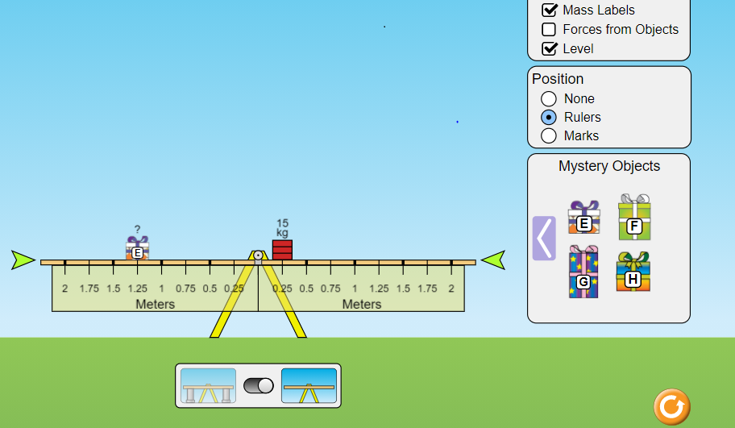
Calculations
Moment=fd
F= force in newton's
D= perpendicular distance in meters from the pivot
F1xd1 = F2xd2
Force= mass x acceleration
Brick: mass= 15kg, distance= 0.25m
Object E: mass=? distance = 1.25m
Force exerted by brick: F= 15kg x 9.8m/s2= 147N
Moment= F1 x 1.25m= 147N x 0.25m
F1= 29.4N
But, Force= mass x acceleration
29.4N=mass x9.8m/s2
Mass of the mystery object E= 3kg
Mystery Object "F"
Seesaw balanced screenshot:
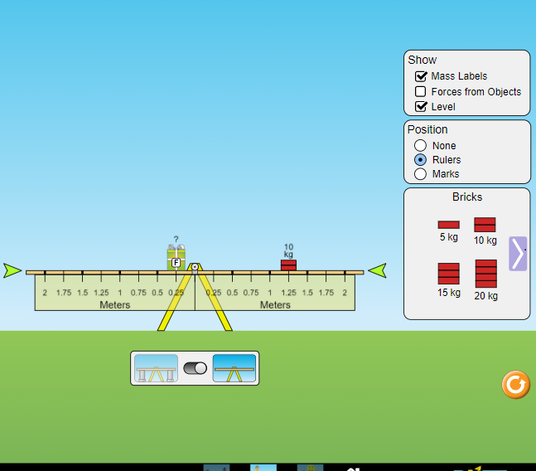
Calculations
Moment=fd
F= force in newton's
D= perpendicular distance in meters from the pivot
F1xd1 = F2xd2
Force= mass x acceleration
Brick: mass= 10kg, distance= 1.25m
Object E: mass=? distance = 0.25m
Force exerted by brick: F= 10kg x 9.8m/s2= 98N
Moment= F1 x 0.25m= 98N x 1.25m
F1= 490N
But, Force= mass x acceleration
490N=mass x9.8m/s2
Mass of the mystery object E= 50kg
Mystery Object "G"
Seesaw balanced screenshot:
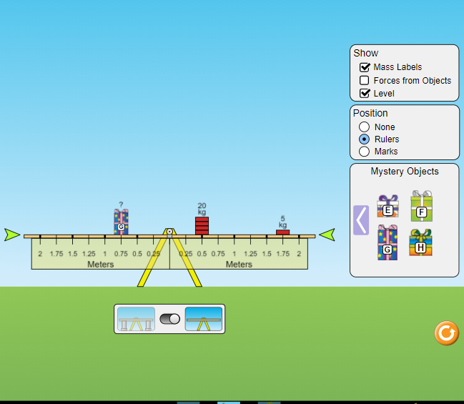
Calculations:
Moment=fd
F= force in newton's
D= perpendicular distance in meters from the pivot
F1xd1 = (F2xd2) + (F3xd3)
Force= mass x acceleration
Bricks: mass= 5kg, distance= 1.75m; mass=20kg, distance= 0.5m
Object G: mass=? distance = 0.75m
Force exerted by bricks: F2= 5kg x 9.8m/s2= 49N, and F3= 20kg x 9.8m/s2= 196N
Moment= F1 x 0.75m= (49N x 1.75m) +(196N x 0.5m)
F1 x 0.75m= 85.75NM + 98NM
F1 x 0.75m=183.75NM
F1= 245N
But, Force= mass x acceleration
245N=mass x9.8m/s2
Mass of the mystery object G= 25kg
Conclusion
A moment or torque is a turning effect of a force around a fixed point, pivot. On a see-saw, the support objects remain at equilibrium when the moments of force exerted on both sides are equal. The size of moments depends on two factors (Song & Park, 2020).
- The actual size of the applied force
- The perpendicular distance measured from the pivot to the action object
The longer the distance from the pivot, the greater the force applied. Light objects should be placed away from the pivot when balancing heavy weights placed near the pivot on the opposite side.

Reference
Song, J., Kim, K., & Park, J. (2020). Do Tangential Finger Forces Utilize Mechanical Advantage During Moment of Force production? Journal of Motor Behavior, 1-17.

